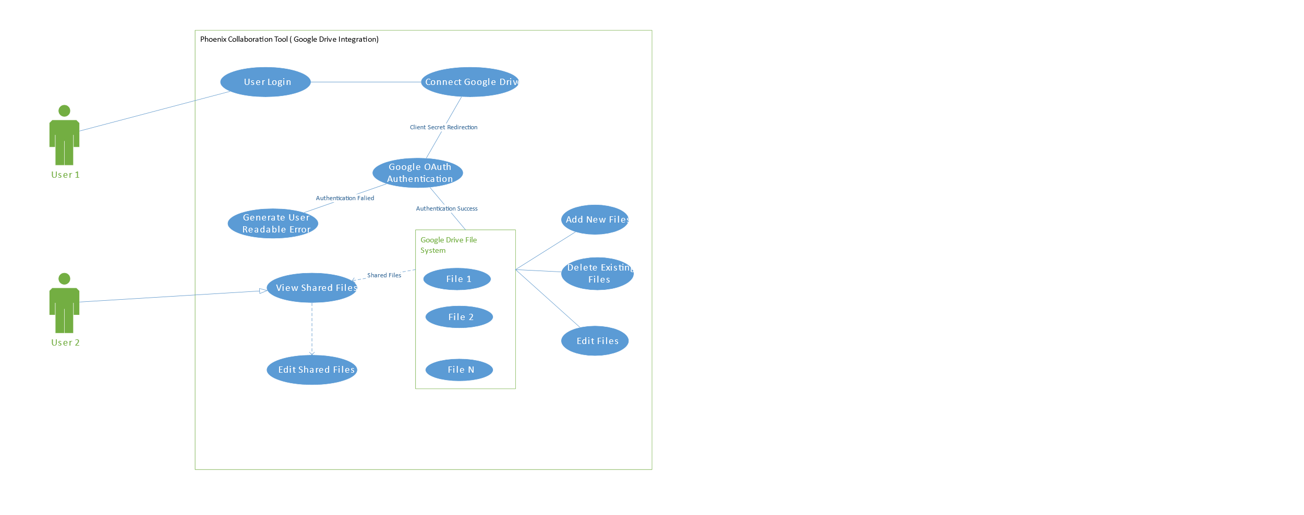

1. User1 needs to login to Phoenix Collaboration Tool get connected to the google services.
2. After Logging in user will have feature to get connected to Google Drive services using Google OAuth Application.
3. The Google OAuth authentication is done using a client secret generated while creating a google Oauth application in Google Drive API Module.
4. Once the authentication token is received the Google Drive filesystem will be displayed and the User1 will have the ability to view, add, delete and edit files in his/her drive.
5. Once the user1 grants the permissions for user2 or any other user to view or edit they will be allowed to view or edit the documents using the permissions granted to them.